Psychology study

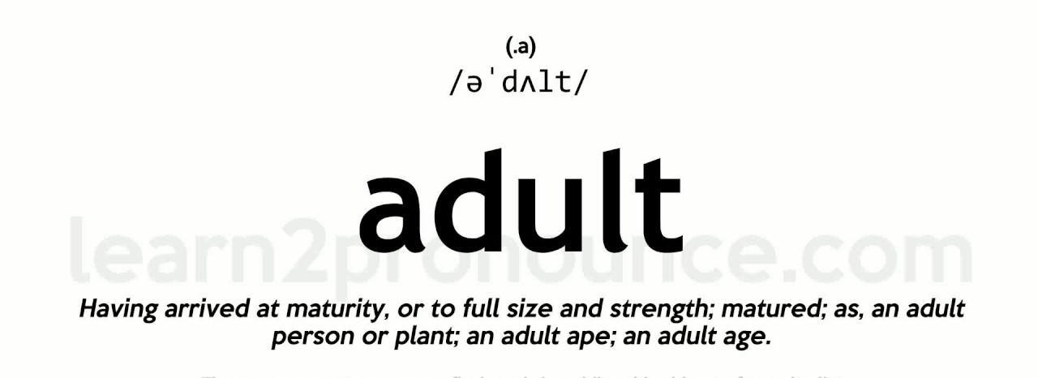



Depression in Youth

Teen depression is a serious mental health problem that causes a persistent feeling of sadness and loss of interest in activities. It affects how your teenager thinks, feels and behaves, and it can cause emotional, functional and physical problems. Although depression can occur at any time in life, symptoms may be different between teens and adults.
Issues such as peer pressure, academic expectations and changing bodies can bring a lot of ups and downs for teens. But for some teens, the lows are more than just temporary feelings — they're a symptom of depression.
Teen depression isn't a weakness or something that can be overcome with willpower — it can have serious consequences and requires long-term treatment. For most teens, depression symptoms ease with treatment such as medication and psychological counseling.


Symptoms
Teen depression signs and symptoms include a change from the teenager's previous attitude and behavior that can cause significant distress and problems at school or home, in social activities, or in other areas of life.
Depression symptoms can vary in severity, but changes in your teen's emotions and behavior may include the examples below.

Emotional changes
Be alert for emotional changes, such as:
- Feelings of sadness, which can include crying spells for no apparent reason
- Frustration or feelings of anger, even over small matters
- Feeling hopeless or empty
- Irritable or annoyed mood
- Loss of interest or pleasure in usual activities
- Loss of interest in, or conflict with, family and friends
- Low self-esteem
- Feelings of worthlessness or guilt
- Fixation on past failures or exaggerated self-blame or self-criticism
- Extreme sensitivity to rejection or failure, and the need for excessive reassurance
- Trouble thinking, concentrating, making decisions and remembering things
- Ongoing sense that life and the future are grim and bleak
- Frequent thoughts of death, dying or suicide



Behavioral changes
Watch for changes in behavior, such as:
- Tiredness and loss of energy
- Insomnia or sleeping too much
- Changes in appetite — decreased appetite and weight loss, or increased cravings for food and weight gain
- Use of alcohol or drugs
- Agitation or restlessness — for example, pacing, hand-wringing or an inability to sit still
- Slowed thinking, speaking or body movements
- Frequent complaints of unexplained body aches and headaches, which may include frequent visits to the school nurse
- Social isolation
- Poor school performance or frequent absences from school
- Less attention to personal hygiene or appearance
- Angry outbursts, disruptive or risky behavior, or other acting-out behaviors
- Self-harm — for example, cutting, burning, or excessive piercing or tattooing
- Making a suicide plan or a suicide attempt

3 Minute Depression Test

This depression quiz is based on the Depression Screening Test by Ivan Goldberg, M.D.
Начало формы
Instructions: Below is a list of questions that relate to life experiences common among people who have been diagnosed with depression. Please read each question carefully, and indicate how often you have experienced the same or similar challenges in the past few months.
Little interest or pleasure in doing things
Not at all
Several days
More than half of the days
Nearly every day
Feeling down, depressed, or hopeless
Not at all
Several days
More than half the days
Nearly every day
Trouble falling or staying asleep, or sleeping too much
Not at all
Several days
More than half the days
Nearly every day
Feeling tired or having little energy
Not at all
Several days
More than half the days
Nearly every day
Poor appetite or overeating
Not at all
Several days
More than half the days
Nearly every day
Feeling bad about yourself - or that you are a failure or have let yourself or your family down
Not at all
Several days
More than half the days
Nearly every day
Trouble concentrating on things, such as reading the newspaper or watching television
Not at all
Several days
More than half the days
Nearly every day
Moving or speaking so slowly that other people could have noticed
Not at all
Several days
More than half the days
Nearly every day
Thoughts that you would be better off dead, or of hurting yourself
Not at all
Several days
More than half the days
Nearly every day
If you've had any days with issues above, how difficult have these problems made it for you at work, home, school, or with other people?
Not difficult at all
Somewhat difficult
Very difficult
Extremely difficult
Конец формы

Газета подготовлена старшим преподавателем кафедры английского языка Акулич Ю.Е. и студентами групп Пс-13, СП-14

